Member: Rui Gao / Caruce

#24, P120

1. Estimate the simple linear regression equation. (5pts each)

R Regression Output

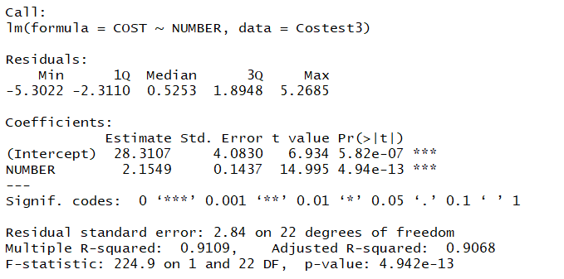

So, the equation is y = 2.1549 x + 28.3107

1. Construct the scatterplot between the predictor variable X and the response variable Y, and draw the fitted regression equation on the scatterplot. (abline function) (13pts each)

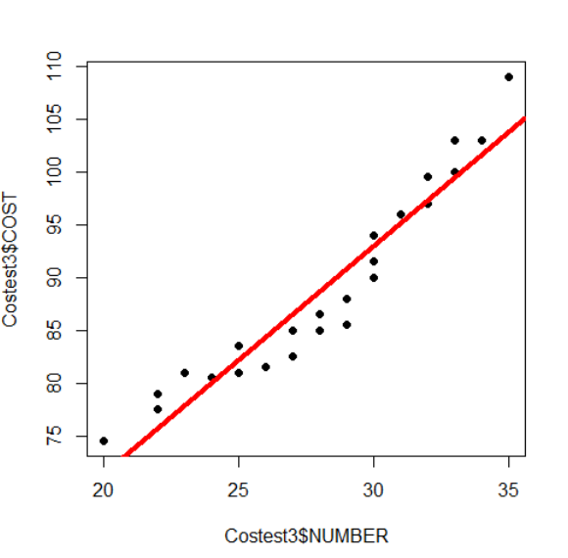

1. Comment on the fitted regression equation (from part (b) above).Interpret the estimated intercept and slope in the context of the problem. (15pts each)

Answer: The intercept shows that the fixed cost is $28.31. The slope shows that when we produce one more product, we would spend $2.15 more.

Should mention "the existence of a curvature structure between COST and NUMBER."

#25, P121

1. Estimate the simple linear regression equation. (5pts each)

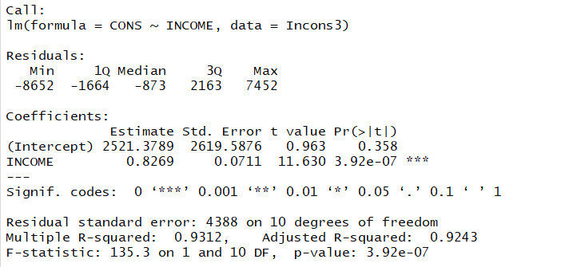

So, the equation is y = 0.8269x + 2521.3789

1. Construct the scatterplot between the predictor variable X and the response variable Y, and draw the fitted regression equation on the scatterplot. (abline function) (13pts each)

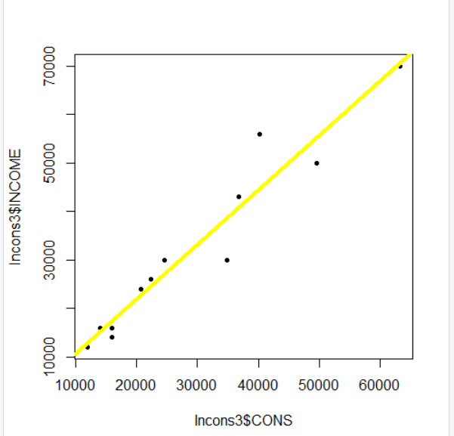

1. Comment on the fitted regression equation (from part (b) above).Interpret the estimated intercept and slope in the context of the problem. (15pts each)

Answer: The intercept shows that the average cost on the goods that are necessary for the 12 families are $2521.37. The slope shows that one more dollar people earn, 0.83 dollar they would like to spend.

Should depict the extent of fitting of the regression line and scatterplot

#26, P122

1. Estimate the simple linear regression equation. (5pts each)

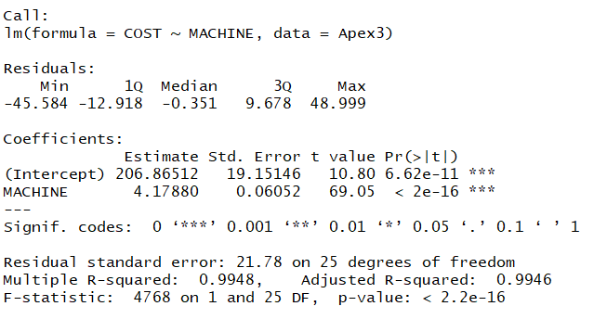

So, the equation is y = 4.1788x + 206.86512

1. Construct the scatterplot between the predictor variable X and the response variable Y, and draw the fitted regression equation on the scatterplot. (abline function) (13pts each)

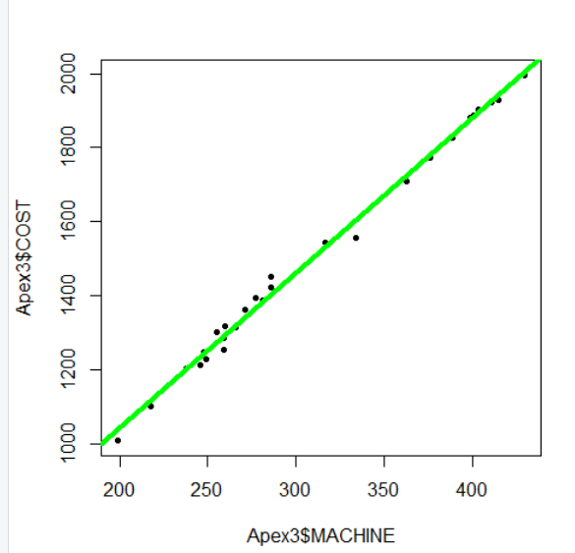

C) Comment on the fitted regression equation (from part (b) above).Interpret the estimated intercept and slope in the context of the problem. (15pts each)

Answer: The intercept shows that the fixed cost, normal operations of the corporation is $206.87. The slope shows that one more hour machine they use per month, they would spend 4.17 dollars per month.

Should say that "the scatterplot and the fitted line equation indicate that the SLR fits the data set very well"